Help File

This help file will assist the User in setting up, navigating and using the database in localhost/ phpMyAdmin.

To begin you are required to download the file to the computer of your choice. The file you downloaded will be a zip file shown in Fig 1. Unzip the file in the location of your choice. Once unzipped the folders contents will consist of those shown in Fig 2.

In order to set up the database in localhost you will need the contents of Database_SQL_file.sql. To do this ensure WampServer64 is running on your computer. It is important that the WampServer logo in the bottom right corner of your screen is green as shown in Fig 3. If the logo is either orange or red as shown in Fig 4, there is an issue with your wamp services, if this occurs you have either not successfully launched WampServer or there is an issue with your install and troubleshooting will be required before proceeding.



Once you have Wamp running successfully you can open localhost in the browser of your choice. When you open phpMyAdmin you will be greeted with a log in screen as shown in Fig 5. Enter the username “root” and leave the password empty. After entering you will be brought to phpMyAdmin.

First you will need to create a database. This can be done by clicking the “new button” highlighted in Fig 7. Once clicked enter the name “group_12_db” into the database name field, also highlighted in Fig 7.

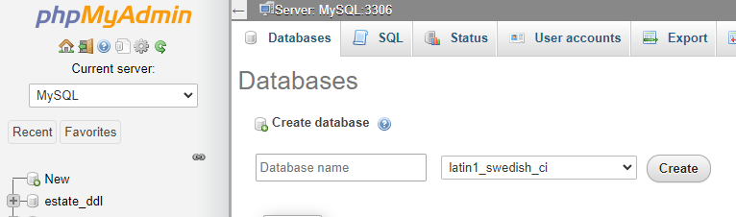

Now you can import the sql file, “Database_SQL_file.sql” to set up the database. Select the “Import” button shown in Fig 6. After selecting this you will be greeted with the screen shown in Fig 8. Select the choose file button highlighted in Fig 8. After selected the User is required to navigate to the location “Database_SQL_file.sql” is stored on their computer. After selecting and uploading the file the database will be created on phpMyAdmin.

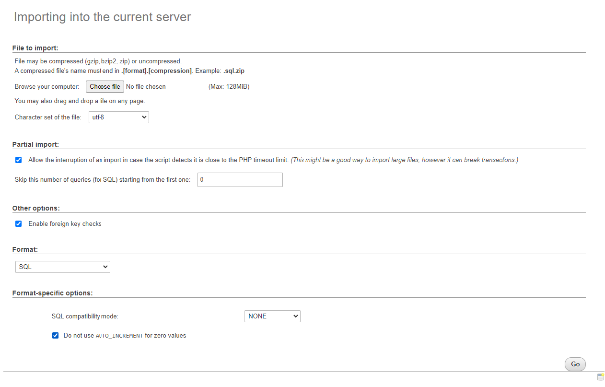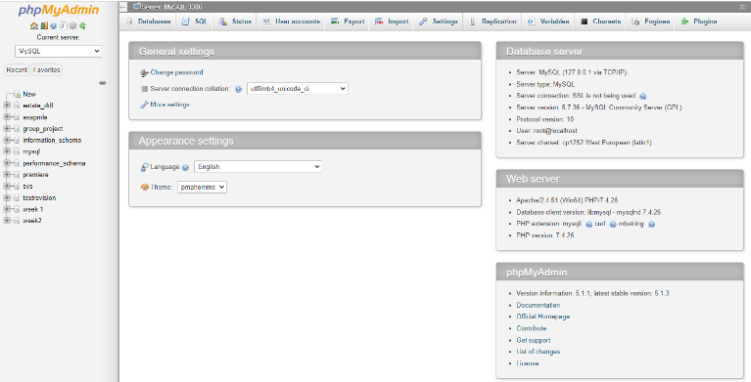

Done correctly and you will have a database with 9 tables each filled with records, shown in Fig 9.